✴

**Build empathy**

The information you add here should be representative of the observations and research you've done about your users.

**SAYS THINK**

I'm so stressed out but i can't take a break

**Do not trust the sales personnel to provide the genuine organic products**

Chemical based farming is not good but what choice do we have?

**Increased pesticides and chemicals also harm the farmland**

**I have too many responsibilities**

**Inorganic products have chemicals. I have been food poisoned sometimes because of it**

Give them a name and a portrait to empathize with your persona.

**I needed to plan my diet properly**

**Perishable produce is spoiled quickly if not bought**

# GAIN

**No worries about food**

Lossing weight and improving physical fitness

**Not many platform to sell directly to consumers**

# PAIN

**Poisoning due to pesicides**

**Health benefits as organic products are very Nutritional**

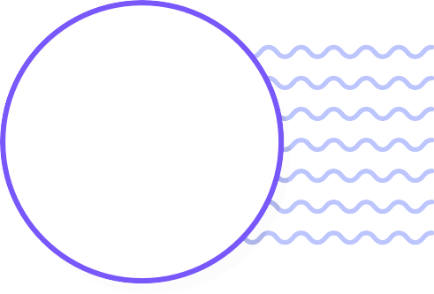

**Empathy map**

Use this framework to develop a deep, shared understanding and empathy for other people. An empathy map helps describe the aspects of a user's experience, needs and pain points, to quickly understand your users’ experience and mindset.

[**Share template feedback**](https://muralco.typeform.com/to/CiqaHVat?typeform-source=app.mural.co)

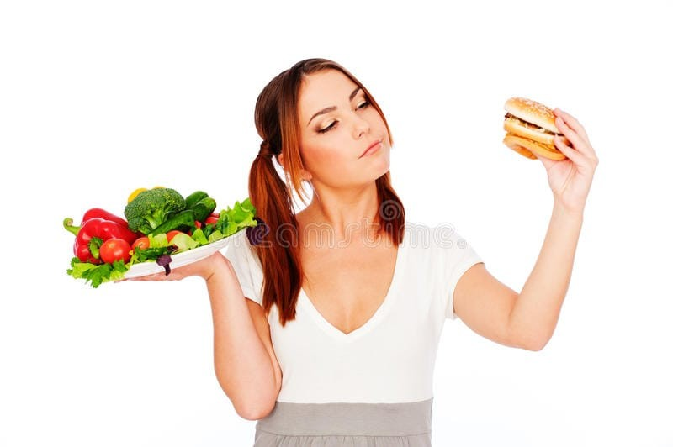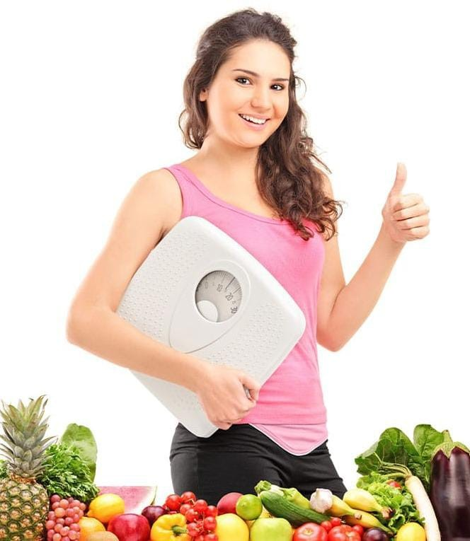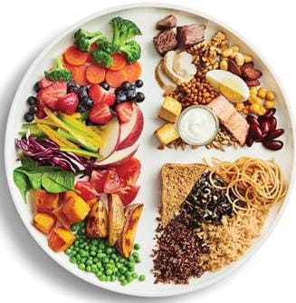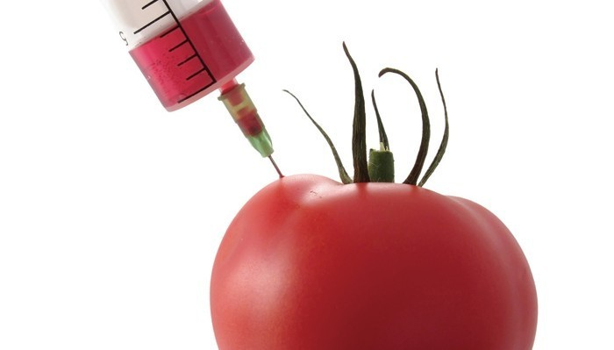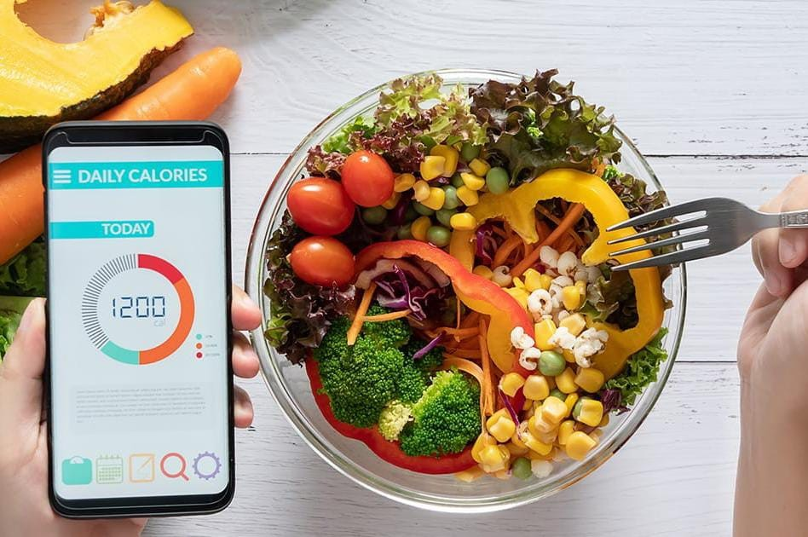

**Template**

**Better Tasting food**

**Farmers need money to start organic farming**

Organic product do not look similar hence people avoid buying those